**Smart water systems**

**Phase 3:IoT**

**In this technology project you will begin building your project by**

**deploying IoT devices**

**and then**

**Developing a Python script on the IoT devices as per the project**

**requirement. After**

**performing the**

**Relevant activities create a document around it and share the same**

**for assessment.**

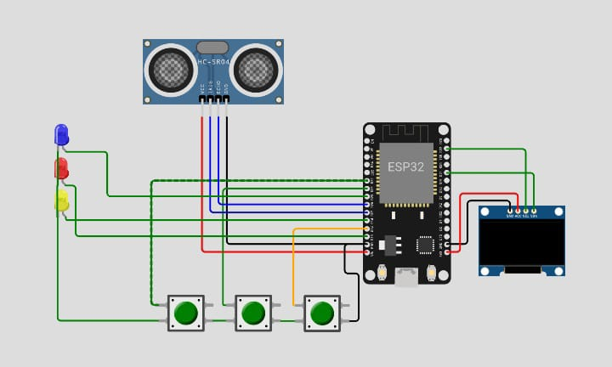**Building our project:**

**cppCopy code**

**#include <DHT.h>**

**#define DHTPIN 4 // Define the GPIO pin to which the DHT22 is connected**

**#define DHTTYPE DHT22 // Define the sensor type (DHT11 or DHT22)**

**DHT dht(DHTPIN, DHTTYPE);**

**void setup() {**

**Serial.begin(115200);**

**dht.begin();**

**}**

**void loop() {**

**delay(2000); // Delay between readings**

**float temperature = dht.readTemperature(); // Read temperature in Celsius**

**float humidity = dht.readHumidity(); // Read humidity**

**if (isnan(temperature) || isnan(humidity)) {**

**Serial.println("Failed to read from DHT sensor!");**

**} else {**

**Serial.print("Temperature: ");**

**Serial.print(temperature);**

**Serial.println(" °C");**

**Serial.print("Humidity: ");**

**Serial.print(humidity);**

**Serial.println(" %");**

**}**

**}**